THE APPLICATION OF THE METHODS
OF SPECIAL SEISMIC PROTECTION

Prof. Vladimir Corneev, DcS
Department of Construction and Mechanics of Structures,
Technical University of Moldova, Moldova
Tel.:
E-mail: vlak_2000@mail.ru

Assoc. Prof. Temenuzhka Bogdanova, PhD
Department of Technical and Natural Sciences, Silistra Branch,
“Angel Kanchev” Univesity of Ruse
Рhone: 086-821 521
Е-mail: tbuhcheva@uni-ruse.bg

Abstract: The paper reviews existing methods of special seismic protection and shows the necessity to use them in the high-rise frame structures. Special attention was paid to the dynamic isolation systems. The purpose was to research the efficiency of rubber isolation bearings and pile foundations with an “intermediate cushion” and to demonstrate the commercial benefits of the special seismic protection. Structural analysis was carried out by a spectral method by means of program SCAD. On the basis of the results was achieved a numerical solution of the problem for a simplified model and for a real 5-storey building. The paper reviews existing methods of special seismic protection and shows the necessity to use them in the high-rise frame structures. Special attention was paid to the dynamic isolation systems. The purpose was to research the efficiency of rubber isolation bearings and pile foundations with an “intermediate cushion” and to demonstrate the commercial benefits of the special seismic protection. Structural analysis was carried out by a spectral method by means of program SCAD. On the basis of the results was achieved a numerical solution of the problem for a simplified model and for a real 5-storey building.
Keywords: E-Learning, Model, Efficiency, Effectiveness, GPS, Protection.

INTRODUCTION
There are many kinds of seismic protection in the field of civil engineering: kinematic foundations, sliding girdle with fluoroplastic for earthquake-proof building, the protecting trench around a building, earthquake-proof buildings, flexible ground floor, rubber isolation bearings (Cooper, A., & Wilson, A., 2002). Seismic forces are directly proportional to the mass of the building and reach their maximum value while resonant vibrations of the system "building-foundation". Non-traditional methods of isolating the structure from its foundation enable an isolated part of the building to vibrate at a frequency which is different from the frequency of the base (non-isolated) part of the building. Then the phenomenon of resonance of the system "building-foundation" does not occur and seismic forces do not reach their maximum value. Thus, special earthquake protection fights with the causes of the dynamic load - seismic forces produced by the system "building-foundation" (Kotler, P., Haider, D. H., & Rein, I., 1993).

EXPOSITION
Investigation of Damping Bearings Using a Simplified Model
A five-meter rod was used as a simplified model (Fig. 1). It was divided into five equal parts. The rod has a square cross section of 400 mm by 400 mm. It was made of concrete (class B25).
Five concentrated masses were applied to the points of the rod (points 2-6). Ten calculations were made using program SCAD. All these ten simplified models had different horizontal stiffness of a damping bearing, K (0; 0,6 t/m; 1 t/m; 5 t /m; 10 t/m; 15 t/m; 20 t/m; 30 t/m; 40 t/m; 50 t/m). As a result of the calculation horizontal displacements (u) of the bottom point of the rod (Fig. 2), bending moments in the rod (M) and seismic forces (Fig. 3) for the points 2-6 of the rod were obtained. Calculation of seismic forces was determined by the formula:
 | $$S_{0ik}=Q_{k}×A×β_{i}×η_{ik}×K_{ψ}$$ | (1)
Q_{k} - the mass of the building in point k; А, β_{i} , K_{ψ}, η_{ik} – coefficients enacted according to literature source (Wirtz, J., Kimes, S., Ho, J., & Patterson, P., 2002).
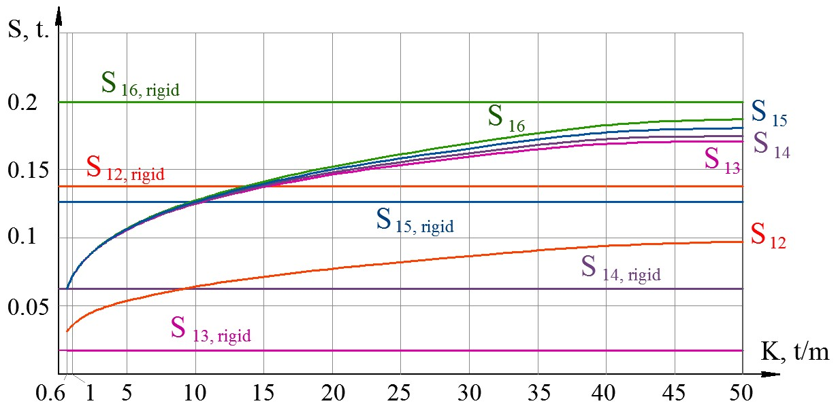
Fig. 3. The relationship between seismic forces (the first mode of vibration) (S_{1i})
and the stiffness of a damping bearing (K)
- in the range from K=0.6 t/m to K =50 t/m (Fig. 3) seismic forces of the two top points of the rod S₁₂ and S₁₆ in the case of a damping bearing are smaller than seismic forces S_{12,rigid}, S_{16,rigid} in the case of a rigid fixed bearing.

Investigation of a Five-Storey Frame Building
To estimate the change in bending moments a new concept ε was introduced. It was called “share of efficiency (ε)”
 | $$ε(K)=\frac{M_{0}-M_{K=Ko}}{M_{0}}=\frac{∆M}{M_{0}}$$ | (2)

M₀ - the bending moment in the element with a rigid fixed bearing; M_{K} - the bending moment in the element with a damping bearing. ΔM - the difference between bending moments.
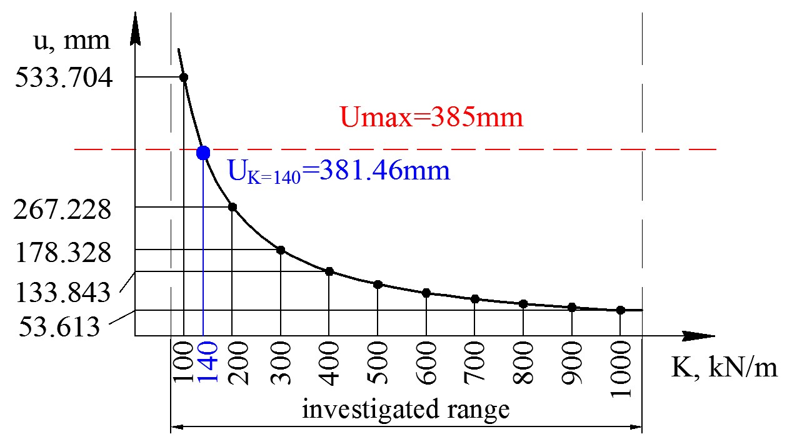
Fig. 4. The relationship between the stiffness of a damping bearing (K) and the horizontal
displacement of the bottom point of the building (u) in the range
from K=100kN/m to K =1000 kN/m
Investigation of a Five-Storey Frame Building with an “Intermediate Cushion”
Horizontal stiffness (K) of an “intermediate cushion" is determined by its composition (sand and gravel), density, thickness. Varying composition, density, thickness it is possible to change elastic modulus (E) and Poisson's ratio (ν) of the “intermediate cushion" (Buhalis, D., 2000). Table 1 shows numerical results of these investigations.
Table 1. Share of efficiency (ε) for the elements of the building
№ | Type of foundation | Share of efficiency (ε) for beams | Share of efficiency (ε) for columns
1 | “bush” pile foundation | 0,209241 | 0,233306
2 | strip pile foundation | 0,122318 | 0,145833
3 | “field” pile foundation | 0,118119 | 0,142239

Investigation of the Efficiency of the Application of the Damping Bearing for Buildings of Different Number of Storeys
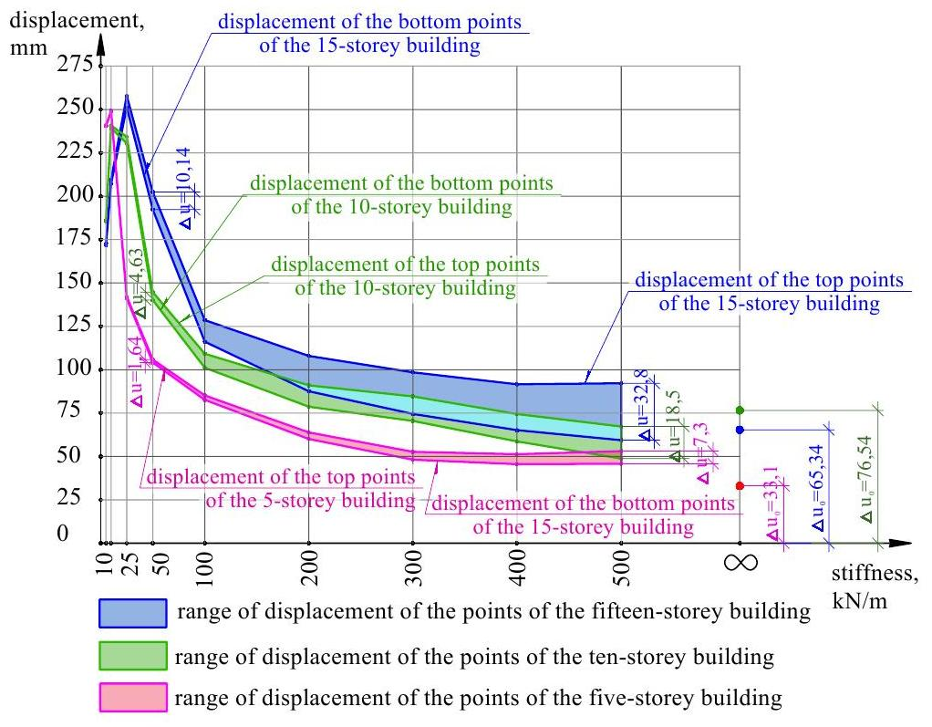
Fig. 6. Ranges of displacement of the points of a five-, ten- and fifteen-storey buildings

CONCLUSION
The building of high-rise houses in high-risk earthquake zones is in a great demand in the modern world. So, damping bearings with low horizontal stiffness allow fulfilling this demand. Thus, application of non-traditional methods of seismic protection in high hazard earthquake areas is especially effective for building hospitals, which require long-term operations and storage centers for fragile items or antiques.

REFERENCES
Bachvarov, M. (2006). Tourism in Bulgaria. In Hall, D., Smith, M., & Marciszewska, B. (eds.) (2006). Tourism in New Europe. The challenges and opportunities of EU enlargement. Wallingford: CAB International, 241-255.
Buhalis, D. (2000). Marketing the competitive destination of the future. Tourism Management, 21(1), 97-116.
Cooper, A., & Wilson, A. (2002). Extending the relevance of TSA research for the UK: general equilibrium and spillover analysis. Paper presented at the VIth International Forum on Tourism Statistics, 25th-27th September 2002, Budapest.
Kotler, P., Haider, D. H., & Rein, I. (1993). Marketing places: Attracting investment, industry and tourism to cities, states and nations. New York: The Free Press.
Wirtz, J., Kimes, S., Ho, J., & Patterson, P. (2002). Revenue management: resolving potential customer conflicts. Working Paper Series. School of Hotel Administration. Cornell University. URL: http://www.hotelschool.cornell.edu/chr/pdf/showpdf/chr/research/working/revenuemanage.pdf (Accessed on 16.12.2005).

Example for resources in Cyrillic - English translation is required
Boteva, M., 2008. Dictionary of Rhetoric – 150 arguments of the speaking. Sofia: Paradigma press (Оригинално заглавие: Ботева, М., 2008. Речник по реторика – 150 аргумента на оратора. София: Издателство „Парадигма”.)

Presented a plenary report of October 27, 2016 with the original title: ПРИМЕНЕНИЕ АКТИВНЫХ МЕТОДОВ СЕЙСМИЧЕСКОЙ ЗАЩИТЫ

